The Cardinal Virtues
Once we have received the gift of sanctifying grace we may not simply "sit back" and believe that we are saved. God calls each one of us to prove our love for him by growing in prayer and good works. A most important way of showing our love is by living the virtues.
A virtue is a permanent power that we have by which we learn to do good and avoid evil. Faith, hope, and charity are supernatural virtues given to us by God. There are other virtues that we must acquire by practice. The four main ones are prudence, justice, temperance, and fortitude. They are called the cardinal virtues because all of our good actions depend or "hinge" upon them. ("Cardinal" comes from a Latin word meaning "a hinge").
These four powers are the foundation of a good life. By practicing them we become virtuous and are strengthened to do great things out of love for God and neighbor.
The Virtue of Prudence
Prudence is the ability to make the right choices in life. Many times we find ourselves in very difficult situations. We are not sure what Christ would do if he were in our shoes. Well, prudence shows us the way; it "tells" us what to do in order to be faithful to Jesus.
Saint Maria Goretti was a twelve year old farm girl who lived near Rome. One summer day, in July 1903, she was murdered by a teenage boy. This young man had wanted Maria to commit a sin against purity with him; he held a knife against her, ready to kill her if she refused. Prudence told Maria that the right thing to do was to scream for help while trying to get away from the attacker. She knew that death was a very real possibility, but she also knew that mortal sin was even worse. No one heard Maria's screams as she was being stabbed. She died the next morning after having forgiven and prayed for her attacker.
Today, Maria is honored throughout the world as a martyr of purity. Prudence showed her the right way - the way that leads to Heaven.
The Virtue of Justice
Justice is the virtue which helps us to live honestly by respecting the rights of others. The just person gives to everyone what he deserves. To God he gives worship; to his co-workers, respect, to his friends, charity and loyalty. Jesus spoke to us about justice when he said: "Treat others the way you would have them treat you" (Mt 7:12).
The unjust person thinks only about his own needs and desires. Pontius Pilate, the leader of the Romans in Palestine, was unjust to Our Lord. When Jesus was brought before him in trial he knew that Christ was innocent. But he also knew that the leaders of the Jews wanted Jesus dead and that it would ruin his political career if he went against their wishes. Thinking only about himself, Pilate condemned Our Lord to Crucifixion. He followed the wrong desires of the crowd instead of sticking up for the truth.
The virtue of Temperance
Temperance is the power to control ourselves. We usually think of it only as having to do with food or drink, but temperance helps us in every situation.
Saint Dominic Savio was an Italian teenager who lived in the middle of the 1800s. He went to a Catholic high school where he soon became the most popular boy in his class. Everyone wanted to be with Dominic because he was so cheerful and good-hearted. After he died at fifteen years of age from a painful illness, a great secret was discovered about Dominic: he had promised God that he would never commit even one mortal sin!
Dominic's confessor told the other boys that he had kept his promise, and these friends wondered how Dominic had done it. They all knew from experience how difficult it was to do good and avoid sin. They found out from their friend's confessor (who was a saint himself: John Bosco) that Dominic was able to keep his promise because of temperance. He never overate, never overslept, never overdid anything. By keeping control over his physical needs Dominic had learned to control his selfish desires too.
The Virtue of Fortitude
Fortitude is the virtue that helps us to face every difficulty or danger with inner peace and courage. It allows us to carry out our duties even if doing so might require great sacrifice and suffering.
All of the holy martyrs of the Church showed fortitude when they chose to remain loyal to Jesus, even though this meant being thrown to the lions or being killed in other terrible ways. Fortitude did not make it easy or take away their fears, but it strengthened them to do what was right no matter what.
There is one young martyr we should all know about. His name was Saint Pancras, and he was only fourteen when he died in the year 304 A.D. Pancras was a very handsome boy and so strong that he always beat the other teenagers in wrestling matches. One day, he won a match against a young pagan boy who was very vain and conceited. To get even, this boy revealed to the Emperor that Pancras was a Catholic. This was forbidden by Roman law.
Well, the Emperor had been a good friend of Pancras' dead father and he wanted to spare the boy. He tried to get him to change his mind. "Just offer some prayers to our gods," the Emperor said, "and I will give you power in the Empire." But Pancras, even though afraid of being killed, refused to deny Jesus. He replied, "By Baptism I am a son of God. I can never give up Jesus Christ, not even for an empire!"
So Pancras was condemned to death. What a courageous teenager he was, as he was led through the streets like a criminal. He did not cry out while the soldiers whipped him, nor did he change his mind as he heard the crowds joke about him. Instead he thought about Jesus being led through the streets of Jerusalem to his Crucifixion. Before he was killed by the sword, Pancras said this prayer which showed his inner peace and fortitude: Thank you, Lord Jesus, for the suffering I am about to receive. I accept it with joy, knowing that my death will bring me to Heaven to be with you for ever. My God, save those who are about to kill me!
We do not have to be martyrs to practice such fortitude! We all have to be strong as we try to live as Christians in a world that does not think much of our holy way of life. We all have to remain loyal to Jesus when friends want us to go out drinking or do other wrongs things. And each one of us can have the same peace and joy that filled Saint Pancras by loving Jesus more than anything else.
Practice Makes Perfect
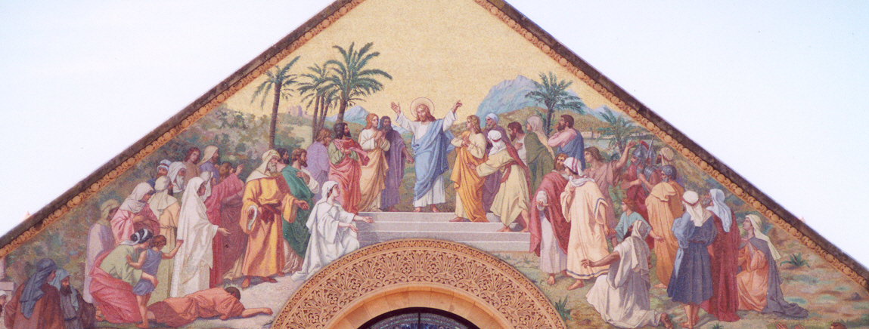
We will all face times in our lives when we will need to be prudent, just, self-controlled, and courageous. So we need to practice these virtues now or else they will not be there when we need them! A priest can show you ways to do this; simply ask him the next time you go to Confession.
By living the virtuous life we will be happy. Jesus assured us of this happiness in his Sermon on the Mount when he promised it to those who live the Christian life. That life is summed up in the eight beatitudes.
The Beatitudes
1. Blessed are the poor in spirit, for theirs is the Kingdom of Heaven.
2. Blessed are those who mourn for they shall be comforted.
3. Blessed are the meek, for they shall inherit the earth.
4. Blessed are those who hunger and thirst for righteousness, for they shall be satisfied.
5. Blessed are the merciful, for they shall obtain mercy.
6. Blessed are the pure of heart, for they shall see God.
7. Blessed are the peacemakers, for they shall be called sons of God.
8. Blessed are those who are persecuted for righteousness' sake, for theirs is the Kingdom of Heaven.

